Exercise Problems for Module 9
- For the following problem, define an ERD for the initial requirements and then revise the ERD for the new requirements. Your solution should have an initial ERD, a revised ERD, and a list of design decisions for each ERD. In performing your analysis, you may want to follow the approach presented in module 8.
The database supports the placement office of a leading graduate school of business. The primary purpose of the database is to schedule interviews and facilitate searches by students and companies. Consider the following requirements in your initial ERD:
- Student data include a unique student identifier, a name, a phone number, an e-mail address, a web address, a major, a minor, and a GPA. Students may attend multiple interviews.
- The placement office maintains a standard list of positions based on the Labor Department’s list of occupations. Position data include a unique position identifier and a position description. Because the position list is standardized, multiple companies may interview for the same position.
- Company data include a unique company identifier, a company name, and a list of positions and interviewers. Each company must map its positions into the position list maintained by the placement office. For each available position, the company lists the cities in which positions are available.
- Interviewer data include a unique interviewer identifier, a name, a phone, an e-mail address, and a web address. Each interviewer works for one company. An interviewer may conduct multiple interviews.
- An interview includes a unique interview identifier, a date, a time, a location (building and room), an interviewer, and a student.

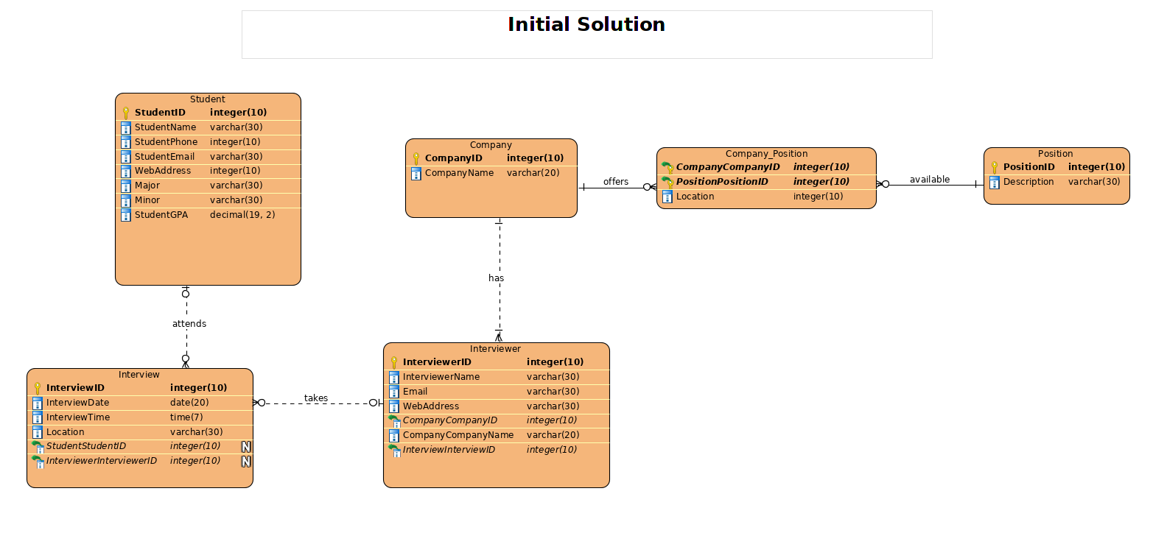

After reviewing your initial design, the placement office decides to revise the requirements. Make a separate ERD to show your refinements. Refine your original ERD to support the following new requirements:
- Allow companies to use their own language to describe positions. The placement office will not maintain a list of standard positions.
- Allow companies to indicate availability dates and number of openings for positions.
- Allow companies to reserve blocks of interview time. The interview blocks will not specify times for individual interviews. Rather a company will request a block of X hours during a specified week. Companies reserve interview blocks before the placement office schedules individual interviews. Thus, the placement office needs to store interviews as well as interview blocks.
- Allow students to submit bids for interview blocks. Students receive a set amount of bid dollars that they can allocate among bids. The bid mechanism is a pseudo-market approach to allocating interviews, a scarce resource. A bid contains a unique bid identifier, a bid amount, a student, and a company. A student can submit many bids and an interview block can receive many bids.
